 | Term 1 & 2 | Term 3 & 4 | Term 5 & 6
Foundation  Stage | 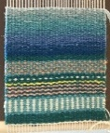  Textiles: Weaving | 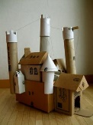  Construction: Buildings Junk Modelling | 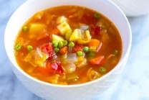  Food and nutrition: Soups
Year 1 | 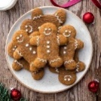  Food and nutrition: Gingerbread | 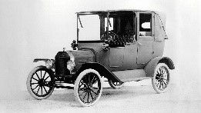  Construction: Vehicles | 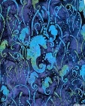  Textiles: Batiks
Year 2 | 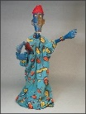  Textiles: Puppets |   Food and nutrition: Pizza | 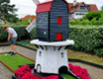  Construction: Mini golf course
Year 3 | 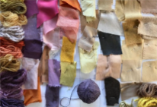  Textiles: Coloured clothing | 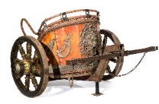  Construction: Chariots | 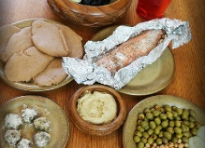  Food and nutrition: Eat like an Ancient Egyptian
Year 4 | 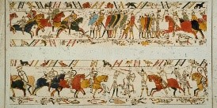  Textiles: Story telling | 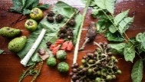  Food and nutrition: Rainforest products | 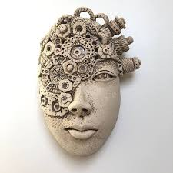  Construction: Sculpture
Year 5 | 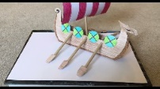  Construction: Viking Long ships | 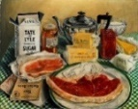  Food and nutrition: Wartime recipe (rationing) | 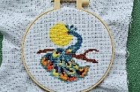  Textiles: cross stitch
Year 6 | 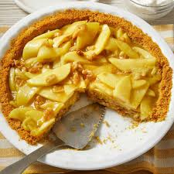  Food and nutrition: Pies | 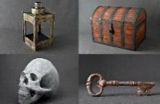  Construction: Props | 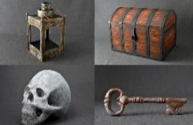  Construction: Props

