Early Years
Books are subject to change, depending on children’s interests and needs.
Term 1 |  | All About Me  Transition, Emotions, Families, Bodies, Senses, Traditional Tale: The Enormous Turnip
Term 1 | 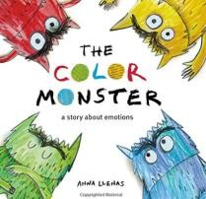 | 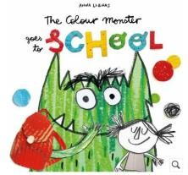 | 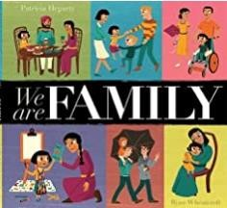 | 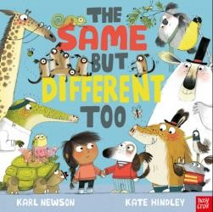 | 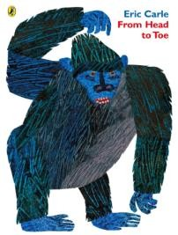 | 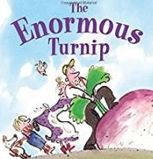  Harvest | 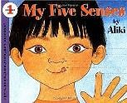
Term 1 | Writing  Opportunities:  Labels: emotion jars | Writing  Opportunities: Labels: map of the school | Writing  Opportunities: Labels: family portraits | Writing  Opportunities: Labels: name writing | Writing  Opportunities:  Labels: body parts | Writing  Opportunities:  Speech Bubbles | Writing  Opportunities: Lists: what do you see/hear/feel/smell/  taste?
Term  2 |  |  | Celebrations  Bonfire Night, Autumn, Birthdays, Diwali, Winter, Christmas |  |  | e
Term  2 | 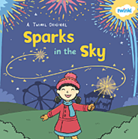 | 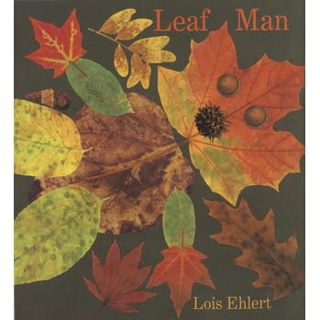 | 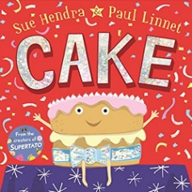 | 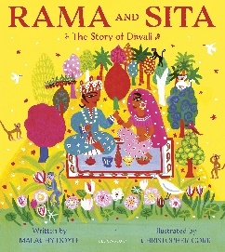  Diwali | 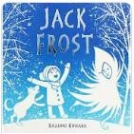 | 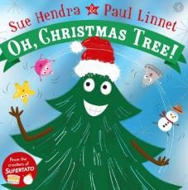
Term  2 | Writing Opportunities:  Onomatopoeia | Writing  Opportunities:  Autumn writing and lists | Writing  Opportunities:  Lists: what do you need for your party?  Invitations | Writing  Opportunities:  Story-telling | Writing  Opportunities:  Wanted Posters | Writing  Opportunities:  Lists: what will you put on your tree? Letters: To Father Christmas
Term  3 |  | Fantasy People  Superheroes, Traditional Tales, Mermaids, Chinese New Year

 | 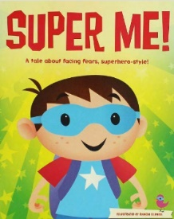 | 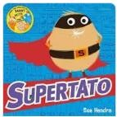 | 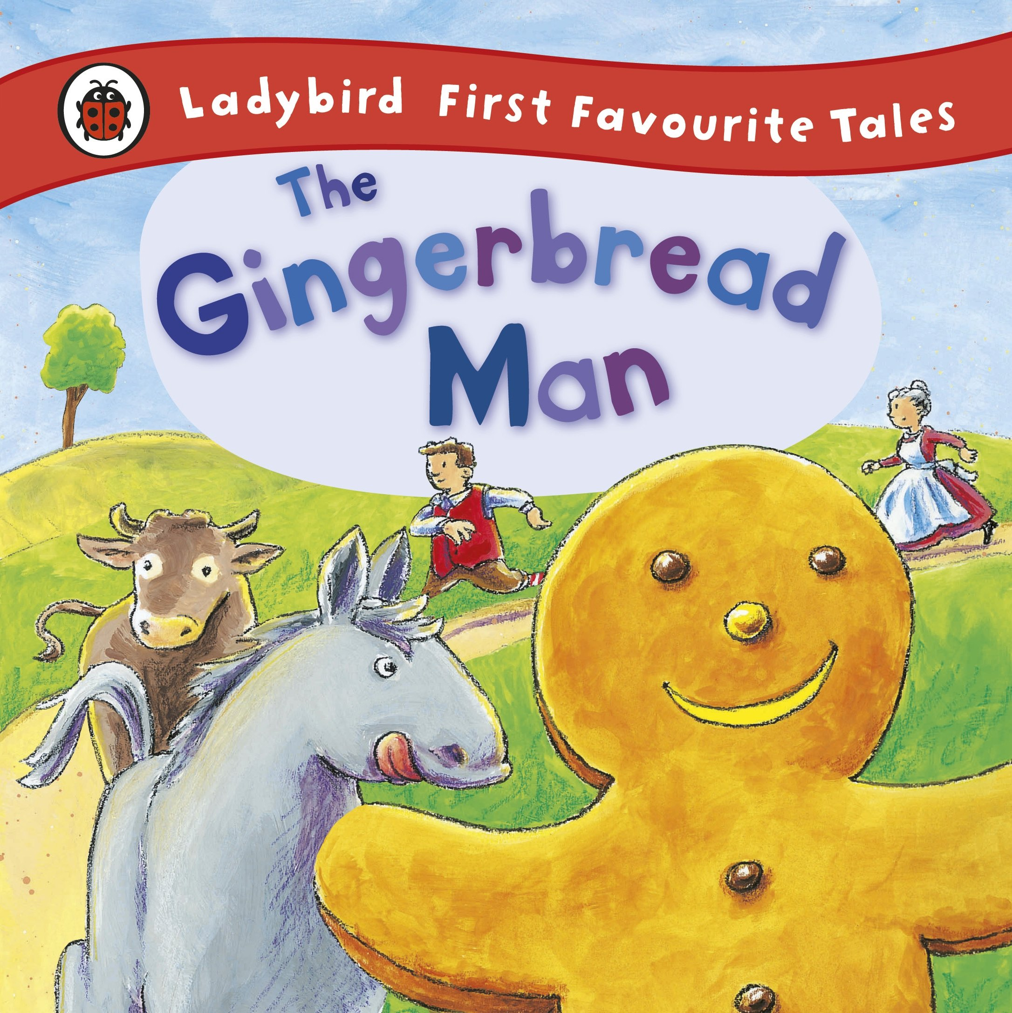 | 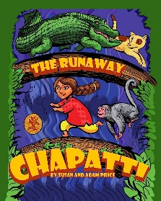 | 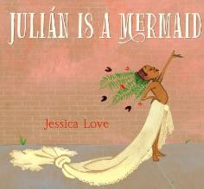 | 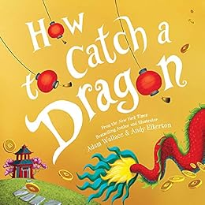
 | Writing  Opportunities:  Simple sentences:  why am I a  Superhero? | Writing Opportunities:  Simple Sentences: What is happening to the vegetables? | Writing  Opportunities:  Story-telling  Story writing | Writing Opportunities:  Story-telling  Story writing | Writing Opportunities:  Simple sentences: Write about your mermaid  Story-telling,  Story writing | Writing  Opportunities:  Simple sentences:  Writing fortune cookie messages
Term  4 |  |  | People who help us  Pancake Day, People who help us,,Traditional Tales  e
Term  4 | 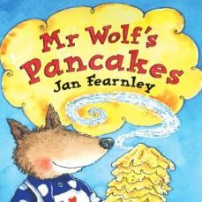 | 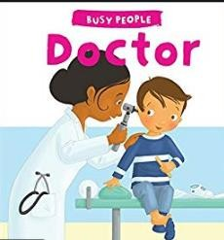 | 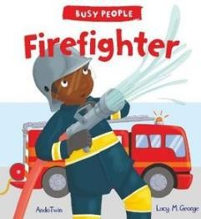 |  | 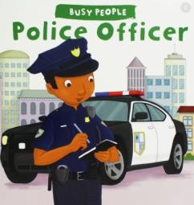 | 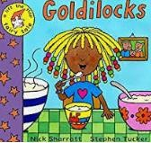
Term  4 | Writing  Opportunities:  Recipe writing | Writing  Opportunities:  Simple sentences: Doctor notes | Writing  Opportunities:  Simple sentences: Firefighter Reports, fire safety instructions | Writing  Opportunities:  Simple sentences: Dentist notes, poster writing | Writing  Opportunities:  Simple sentences: Police Reports, why are they in jail? | Writing  Opportunities:  Story-telling,  Story writing,  Wanted posters
Term  5 | Animals and Environments  Plants, Birds, Reptiles, Woodland Animals, Farm Animals, Zoo Animals, Traditional Tale, Taking care of the environment
 | 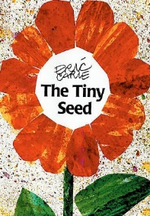 | 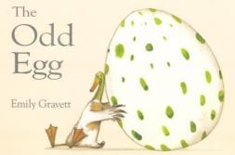 | 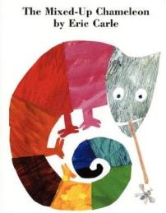 | 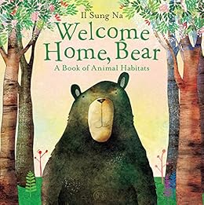 | 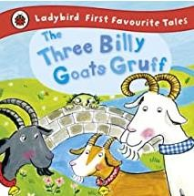 | 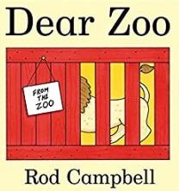 | 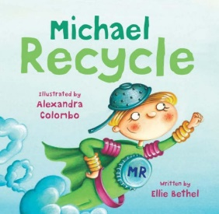
 | Writing Opportunities: Simple sentences: What does a seed need to grow? | Writing  Opportunities:  What is inside your egg? | Writing  Opportunities:  Simple sentences /  Labels:  What does your chameleon turn into? | Writing  Opportunities:  Simple sentences:  Which animal could live in this habitat? | Writing  Opportunities:  Simple sentences:  Story-telling  Story writing | Writing  Opportunities:  What did the zoo send to you? | Writing  Opportunities:  Simple sentences: What can be recycled? Poster writing
Term  6 |  |  | Plants and Food  Rhyme, Food, Father’s Day, Transition |  |  | e:
Term  6 | 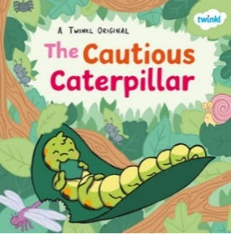 | 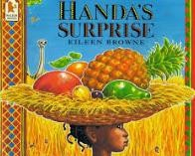 | 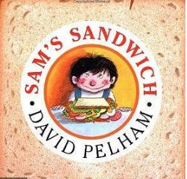 | 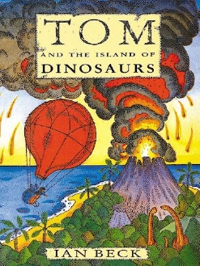 | 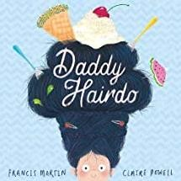 | 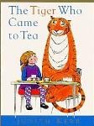 | Poetry to be confirmed
Term  6 | Writing  Opportunities: Simple sentences:  Information about yourself | Writing  Opportunities:  Simple sentences: about fruit  How to make fruit Kebabs | Writing  Opportunities: Recipe writing  Menu writing | Writing  Opportunities:  Instruction Writing: L Letter writing  Escape plans  Recounts  Maps labels | Writing  Opportunities:  Simple sentences: describe your hairdo from Daddy | Writing  Opportunities:  Simple sentences: what will your visitor eat?

