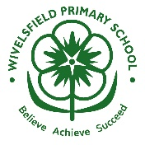
English: Little People, Big Dreams- Poetry and magazine article.
Design and Technology: Materials- re-design paper aeroplanes to be the best they can be- test different materials and have a flying competition.
Maths: Place value, addition and subtraction.
Science: Animals including humans: Nutrition, Hygiene and Lifecycles. Discovering the basic needs of all living things including Humans.
History: What events lead to the great fire of London and what changed as a result.

Science Vocabulary:
birds, fish amphibians reptiles mammals invertebrate carnivores herbivores omnivores baby toddler child teenager adult growth nutrition respiration healthy grow strong energy hygiene
Cross-curricular links:

Learning events:

-
- Paper aeroplane competition

On Safari:
How does life in the UK compare with life in Kenya?
Key questions:
How did we learn to fly?
When was the first flight?
Why is Amelia Earhart significant?
Why was the moon landing special?

Key vocabulary:

(beyond) living memory inventor
lifetime achievement eyewitness
evidence historic past present
flight aeroplane glider
shuttle space lunar

