 | Term 1 & 2 | Term 3 & 4 | Term 5 & 6
Foundation  Stage | 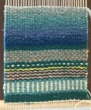  Textiles: Weaving | 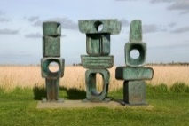  Construction: Barbara Hepworth | 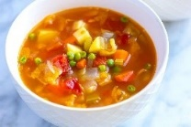  Food and nutrition: Soups
Year 1 |   Food and nutrition: Gingerbread | 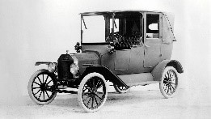  Construction: Vehicles | 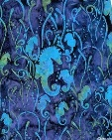  Textiles: Batiks
Year 2 |   Food and nutrition: Pizza | 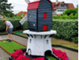  Construction: Mini golf course | 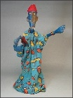  Textiles: Puppets
Year 3 | 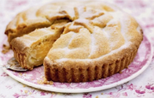  Food and nutrition: pies | 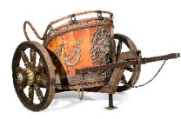  Construction: Chariots | 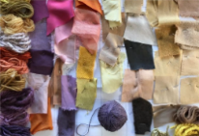  Textiles: Coloured clothing
Year 4 | 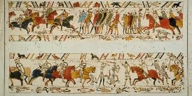  Textiles: Story telling | 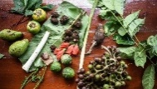  Food and nutrition: Rainforest products |   Construction: Lanterns
Year 5 | 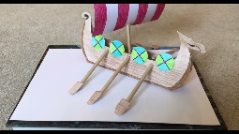  Construction: Viking Long ships | 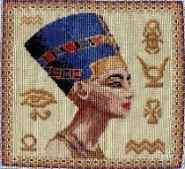  Textiles: Egyptians cross stitch | 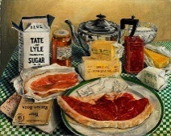  Food and nutrition: Wartime recipe (rationing)
Year 6 | 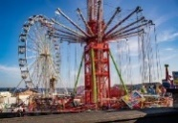  Construction: Fairground rides | 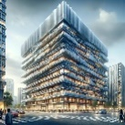  Construction: Earthquake resistant buildings | 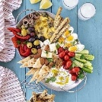  Food and nutrition: Greek Meze

