 | Term 1 & 2 | Term 3 & 4 | Term 5 & 6
Foundation  Stage | 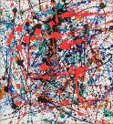  Jackson Pollock | 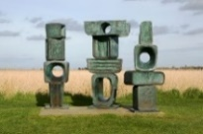  Barbara Hepworth | 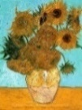  Vincent Van Gogh
Year 1 | 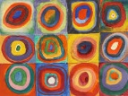  Wassily Kandinsky | 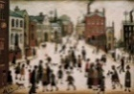  LS Lowry | 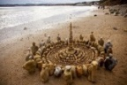  Andy Goldsworthy
Year 2 | 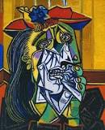  Pablo Picasso | 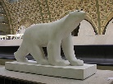  Francios Pompon | 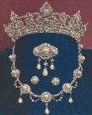  Jewellery fit for a Monarch
Year 3 | 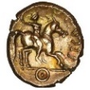  Coins | 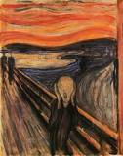  Edvard Munch | 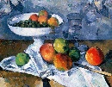  Paul Cezanne
Year 4 | 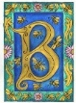  Illuminated letters | 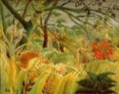  Henri Rosseau | 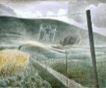  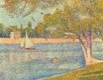  Georges Seurat &Eric Ravilious
Year 5 | 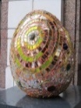  Andrew Logan | 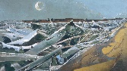  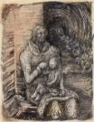  Paul Nash / Henry Moore | 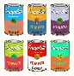  Andy Warhol
Year 6 | 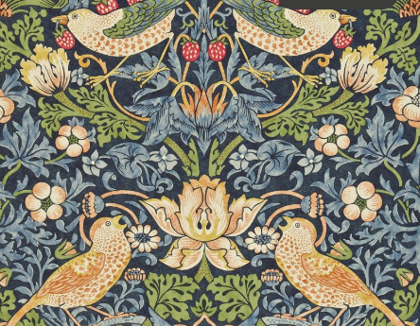  William Morris | 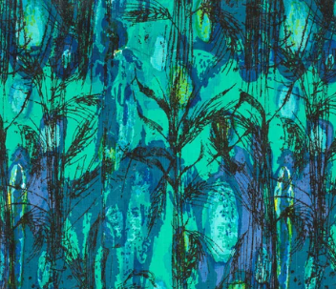  Althea McNish | 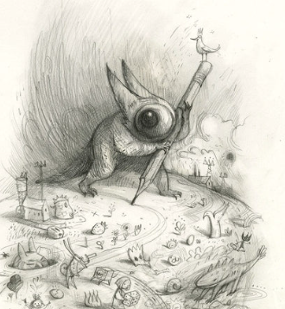  Portraits – Shaun Tan, Kay Lovesah and Mike Barrett

